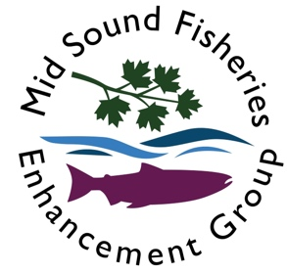
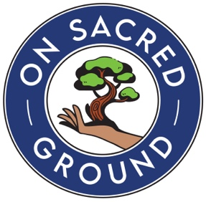
PARENT/GUARDIAN & PARTICIPANT LIABILITY RELEASE
For All Participants

BY SIGNING THIS FORM, I AM RELEASING ON SACRED GROUND AND MID SOUND FISHERIES ENHANCEMENT GROUP FROM ANY AND ALL LIABILITY IN THE EVENT MY CHILD IS INJURED, DAMAGED OR KILLED WHILE PARTICIPATING IN THIS PROJECT OR PROGRAM SPONSORED BY ON SACRED GROUND AND MIDSOUND FISHERIES ENHANCEMENT GROUP. I UNDERSTAND THAT I COULD HAVE THIS RELEASE REVIEWED BY A LAWYER OF MY CHOICE.

Understanding the foregoing paragraph, I wish for my child to participate in this project sponsored by On Sacred Ground (OSG) and Mid Sound Fisheries Enhancement Group (MSFEG). I am aware that events and projects sponsored by OSG and MSFEG may involve hiking, backpacking, camping, games, marine travel and other recreational activities (including but not limited to running, jumping, light contact sports); and that participating in or observing these events or projects poses certain dangers, including, but not limited to, the hazards of traveling in and hiking in wilderness terrain; the hazards of navigating the Salish Sea from a kayak or canoe; using hand tools (and of hiking and working in the proximity of such tools when used by others); injury or illness in remote places without medical aid; and unforeseen events caused by the forces of nature. In consideration for permitting my child to participate in projects sponsored by OSG and MSFEG, I, for my family, my estate, and myself, hereby waive any right of recovery and claims of liability against OSG and MSFEG, its officers, employees and agents, including claims for bodily injury, death, personal injury and/or damage to property, and release OSG and MSFEG, its officers, employees and agents from any claims made by others for personal injury or property damage allegedly caused by me or my child while engaged in any OSG / MSFED sponsored activity. Further, I will hold OSG and MSFEG harmless from any loss or damages resulting from the foregoing waiver and release. This Release and Indemnity Agreement is a contract, not a mere recital and thus it shall remain in effect for all projects sponsored by OSG and MSFEG in which my child participates. I also give permission for my child to be photographed/filmed and have his or her image used by OSG, MSFEG and their partner agencies (National Park Foundation and San Juan Island National Historical Park), without royalty or compensation.

As Parent/Guardian, I am signing on behalf of a minor, I further agree to HOLD HARMLESS AND INDEMNIFY OSG and MSFEG and its members from all liability, claims and causes of action which the minor may have arising from the minor’s participation in activities. The terms of this agreement shall serve as a release and indemnity agreement for my heirs, personal representative, and for all members of my family, including any minors.

I HAVE READ AND AGREE TO ABIDE BY THE OSG AND MSFEG LIABILITY RELEASE AND AGREE I HAD THE OPPORTUNITY TO MAKE CHANGES OR SUGGEST CHANGES TO THIS AGREEMENT, BUT I MADE NO ATTEMPT TO ALTER OR CHANGE THE WORDING.
Parents or legal guardians must sign for all persons under eighteen (18) years of age. Participant Name:
Parent /Guardian Name:

Parent /Guardian Signature: Date:

I/my child choose to opt out of the media release (write yes if you do not give permission for media release):

